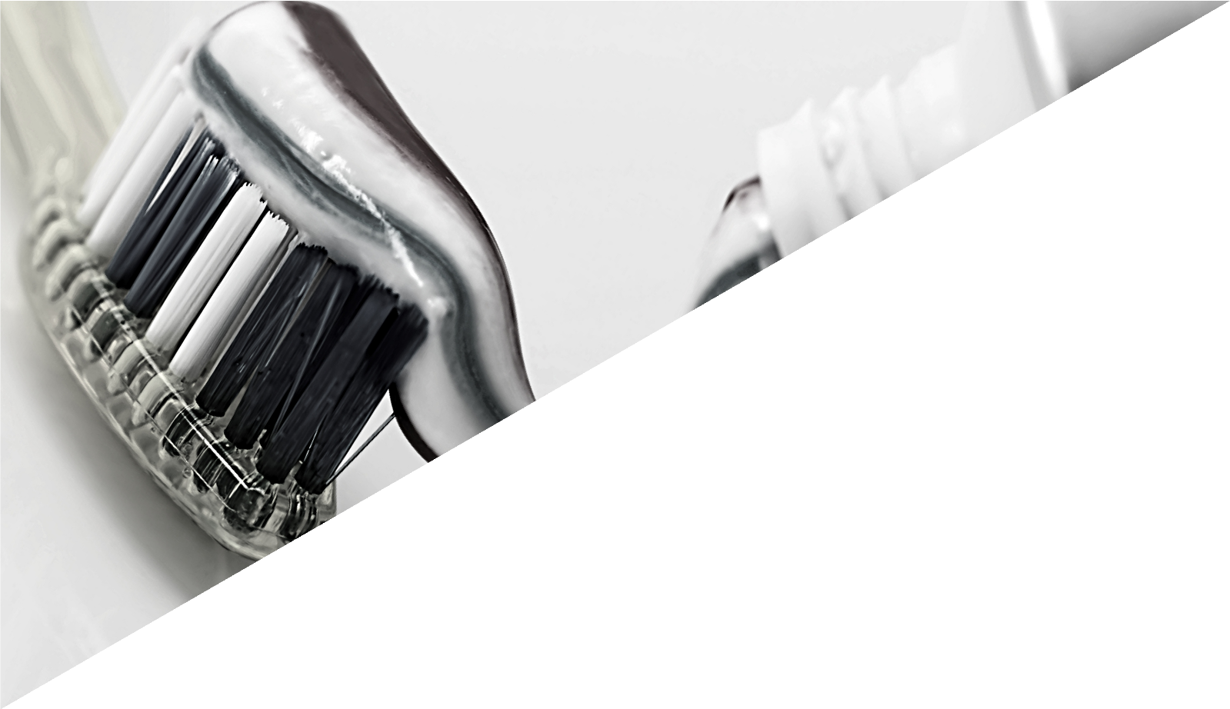

A WELCOME FROM THE DEAN

“I am very pleased to welcome you to The Institute of Dentistry here at Queen Mary University of London.

Our Dental School has a rich and glorious history. It is a very special place and a place that you can be proud of.

We have a strong global reputation. You have chosen us and we have chosen you and welcome you to our world-class, research informed, modern teaching environment. You will be the best and will stand proud as a Queen Mary Graduate when you finish your training. We pride ourselves in developing you to deliver whole patient care and be scientists, scholars, critical-thinkers as well as being socially responsible. All of you will be equipped to make a difference. Not only will our Education offer you immense opportunities and change your life, it will also allow you to change the life of those you treat. You will have lots of fun and make many life-long friends.

I am a proud graduate of this Institute and University and know that you will be one too. Enjoy the Induction Week and settle in as you embark on the adventure of a lifetime……”

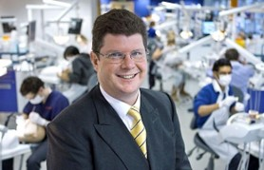
Professor Christopher Tredwin
Dean & Institute Director,
Professor of Restorative Dentistry at Institute of Dentistry, QMUL
Consultant in Restorative Dentistry, Bart's Health NHS Trust

