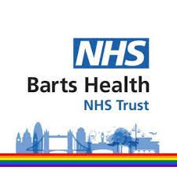
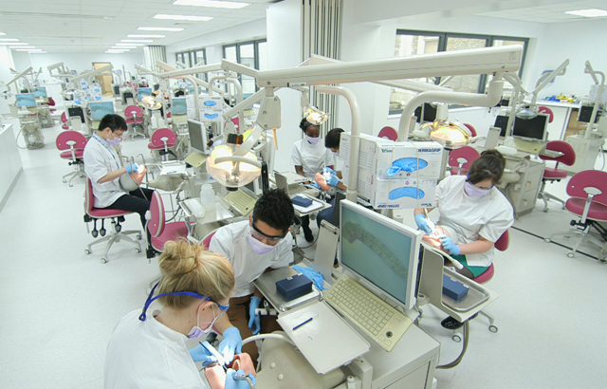

Clinical Postgraduate Induction Handbook

Table of Contents
Student ID Cards 3
NHS ID Card 4
QMUL ID Card 4
CRS Card 4

Processes and Policies 5
Trust Network Log In 6
NHS.net Email Account Log In 6
Barts Heath ID and Completing your Training 7 - 9
Honorary Contract Process 10
Occupational Health Checks 11
DBS Checks 12
Attire for Clinics and Labs 13-14
Scrubs 15
Annual leave and unplanned absences 16
Support and Resources 17
Organisations offering support outside of QMUL 18

Contacts 19
PGT Timetabling and Curriculum Support 20
Student Support Office 21
Library Services & Directors of Education 22
Directors of Education & Programme Leads 23-26

Students and Location 27
Locating the Dental Hospital 28
Navigating the Dental Hospital 29
International Students……………………………………………………………………………………………..30-33

Student ID Cards

Getting your NHS ID card
Your NHS ID card allows you to access certain parts of the Dental Hospital.

- First you must collect the prefilled application form from: Office 5, fourth floor of the Dental Hospital.
- This should be completed and taken to the: Main reception of the Royal London Hospital (Stepney Way Entrance).
- Please take a form of photo identification with you upon collection.

Getting your QMUL ID card
Your QMUL ID card allows you to access the printers and the QMUL library.

- This card must be collected from the Student Enquiry Centre http://www.arcs.qmul.ac.uk/students/sec/
- Please contact them for all queries regarding your QMUL card.

Getting your CRS card
Your CRS card allows you to use the NHS Patient Record System (called “Millennium”) on clinic.
- You will receive a link from Millennium training to complete your CRS training
- Once complete, you must then collect two forms from Office 5 on the fourth floor of the Dental Hospital. These forms are titled:
- CIS – Position Assignment Modification
- CIS – Create New User (RA Use Only)
- Both forms must be completed and taken to the 10th Floor Reception Desk, (between Ward 10F and Ward 10E), in the main Royal London Hospital.
Please see below their opening times:

Mondays and Wednesdays, from 8:30 – 11.30am
Tuesday - 8:30 – 11:30am
Thursday – 1:30pm – 16:00pm
Friday - 8:30 – 11:30am

- You MUST take with you one form of photo identification and two proof of address OR two forms of photo identification and one form of address.
- The staff on the 10th floor will then process your forms and create your card. They will provide instruction on when to collect.

Processes
and Policies

Non-clinical programmes – this section does not apply to any students on a non-clinical programme.
Trust Network Log In
Your Trust network log in will allow you to log in to a Trust computer.

Here is a step by step process of getting your Trust network log in:
- Your log in would have already been requested for you ahead of you enrolling into QMUL.
- You should receive an email from either the Trust IT or the Student Support Administrator for QMUL with your network log in details.
- If you do not receive these when during your induction week, please let the Student Support Administrator know so they can be given to you.
Please note that you need to log in WEEKLY to your Trust account otherwise your account will be deactivated, and you will need to re start the process again.

NHS.net Email Account Log In
These log in details will allow you to access your NHS email account.

Here is a step-by-step process to get your NHS email account:
- Your email account would have already been requested for you ahead of you enrolling into QMUL by the Student Support Team.
- You should receive an email from either the Trust IT or the Student Support Administrator for QMUL with your email account log in details.
- If you do not receive these during your induction week, please let the Student Support Administrator (Zara Mabey – z.mabey@qmul.ac.uk or Zehra Sonerman z.sonerman@qmul.ac.uk ) know so they can be given to you or contact dental.sso@qmul.ac.uk.

Please note that you need to log in to your nhs.net e-mail account at least every two weeks to keep it active.

Barts Health ID and Completing your Training
It is an obligatory requirement to complete all statutory and mandatory training BEFORE commencing clinical sessions.
A Barts Profile ID must be created in order to complete your statutory and mandatory training.

Here is a step-by-step process to get your Barts Health ID:
(Zoom in for a better view of the screenshots)

- First, please go to this website via the following link: | https://learning.bartshealth.nhs.uk/
- Then click ‘Create Profile ID’ | 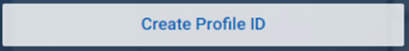
- You will then be prompted to put in your full name and click next.

- Your employment details are to be filled in as follows:  Please leave the employee number blank and click next. | 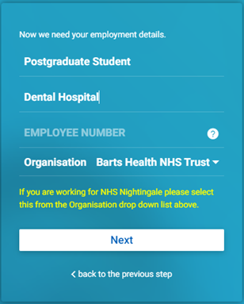
- For the next section, click ‘yes’ or ‘no’ depending on what applies to you. (Clinica PGs only training at BartsHealth should click ‘no’) | 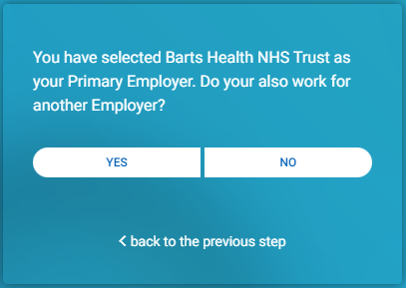
- Next, enter your email address (please use the email address you will find easiest to access)  If you do not have an NI (National Insurance) number then you can create one by using the capital letters TN, followed by the 6 digit format of your date of birth followed by the initial of your surname.  (For example, Mr Smith with a date of birth 8th April 1970 would be TN080470S)  Once you have done this, please click the ‘encrypt’ button. | 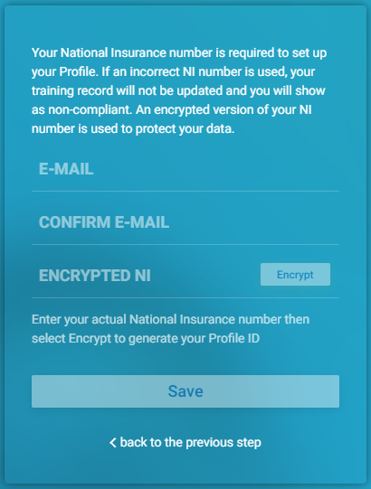
- Once you see this message, go to the email account you input previously and you will receive a 16 digit Profile ID – This is the ID you need to enter on the front page to sign in. | 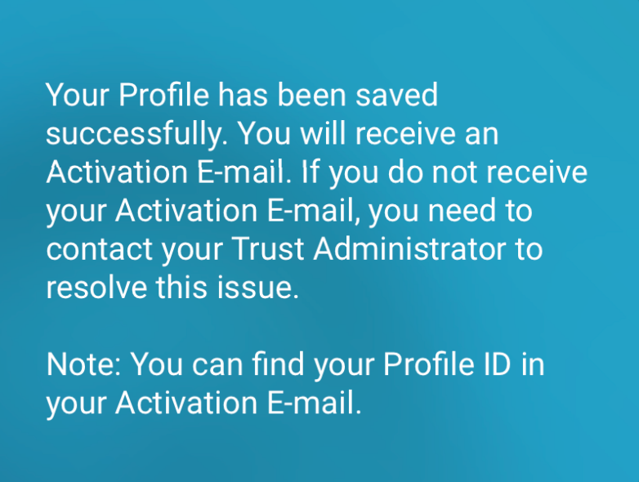
- Now that you have your 16 digit Profile ID, please go back to the link in step 1 and use it to sign in. | 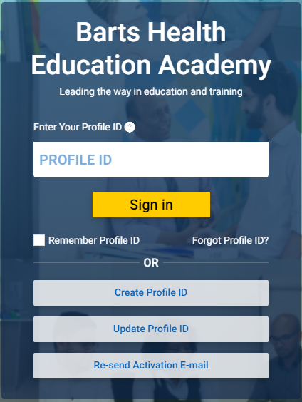
Once you are signed in…
- Click the ‘Dental’ tab which will take you to the Dental Specific page. | 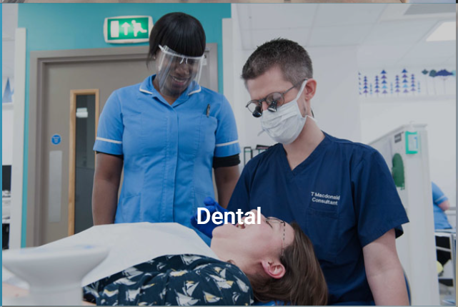
- Go to the ‘E-Learning’ tab and then proceed to the ‘COVID-19 Resources for Revision, Upskilling and Training’ section. | 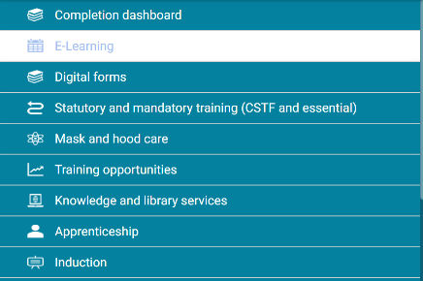
- Next, click on the ‘Dentists’ tab. | 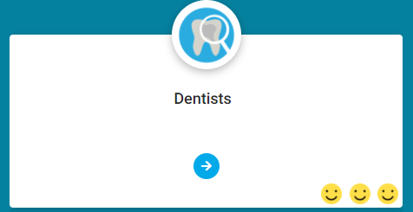
- Go to the ‘Clinical Skills Lab Training For undergraduates’ section and complete:  - Donning and Doffing in the DH  - Mask Fit Testing in the DH | 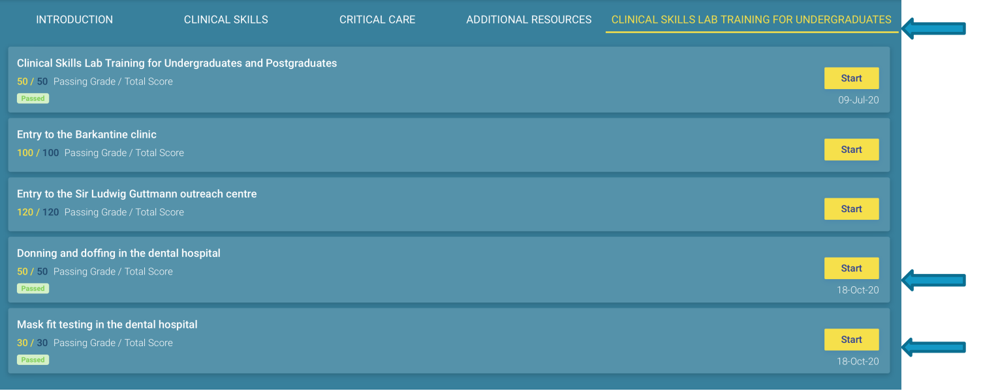
- One complete, go back to the ‘Statutory and Mandatory Training (CSTF and Essential)’ section. | 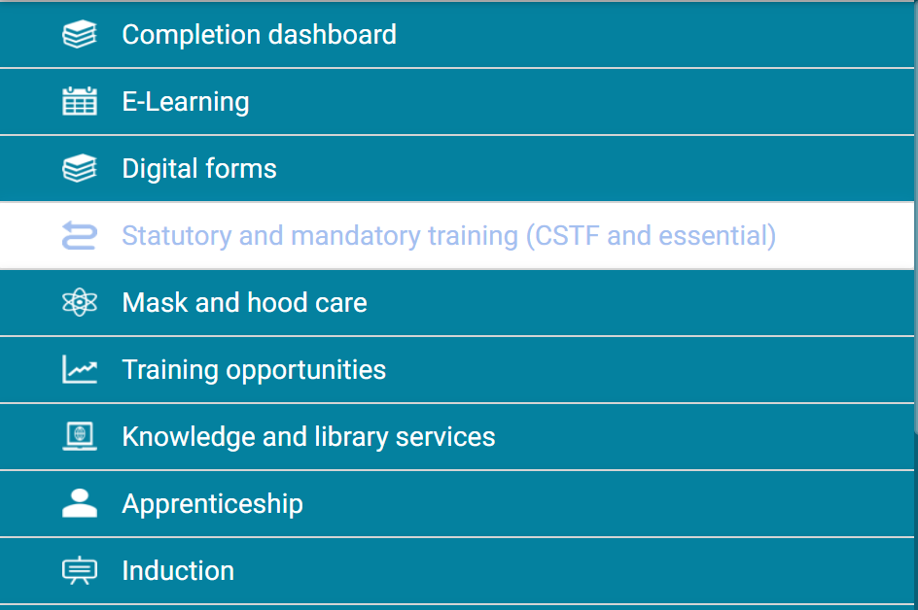
- You must now complete all of the essential training listed in the PDF in step 16 in each of the three tabs. | 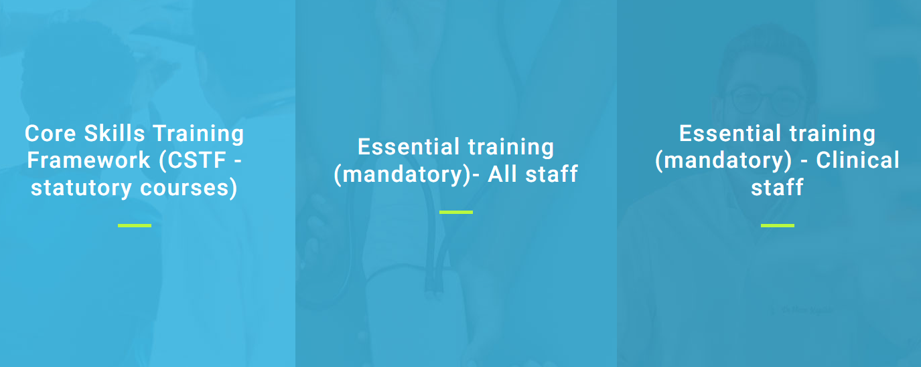
- Here is a PDF list of the essential training you must complete. | Please click here for the list of training List of Essential Training for PGTs (Barts Profile ID Process).pdf (sharepoint.com)

Honorary Contract Process
All Postgraduates enrolled on programmes which require you to be present in a Barts Health clinical environment will need an honorary contract.
Here is a step-by-step process to get an honorary contract:
- Receive, via email, the pre-filled honorary contract request form from the Student Support Administrators at dental.sso@qmul.ac.uk or (Zara Mabey – z.mabey@qmul.ac.uk or Zehra Sonerman z.sonerman@Qmul.ac.uk ).
- You must populate the unfilled sections of the form and return, via email, to the Student Support Administrator.
- Please do not change the pre-populated sections of this form.
- Once complete, please return to the Student Support Administrator.
- This will then be sent to the NHS Director of Dental Education, Lochana Nanayakkara for approval.
- Once the honorary contracts team begins processing your request form, they will contact you with a link to complete the process.

Occupational Health Checks (Clinical Students Only)
All clinical students must have these checks in order and get formal clearance to be able to go onto clinics.

- By September, you will have received an email with a link to an online health questionnaire.

http://www.healthquestionnaire.co.uk/qmulstudents2022

- It is important that you complete this as soon as you can so your appointment can be booked with the occupational health team.

- Additionally, ensure that your vaccines are up to date and make sure you have proof of your vaccination history when you attend the occupational health appointment.

- At your appointment, you will have blood samples taken. These will be ready in approximately 3 weeks from your appointment date.

- You can check if your immunisation report is ready by emailing the occupational health team (qmulstudents@ohworks.co.uk) and for if you have any queries.

- Please read through the guide below for further information (double click)
Disclosure and Barring Service (DBS) Checks
(Clinical Students Only)
All clinical students must have these checks in order to go onto clinics.

You should have received an email invitation to initiate your DBS application. (This will have been sent to the registered email address that you provided)
In order to complete your DBS, you will need a UK address with proof of address.
Common FAQ’s
· I cannot log in or I have forgotten my password.
Please do check that you are using the correct email address. You can reset your password but Queen Mary are not able to do this for you.
· What Documents do I need?
You will have the option to choose the documents that you provide. At least one document needs to be proof of the UK address that the certificate will be dispatched too. If you put a temporary address and cannot access the delivery of the certificate you will have to re-do the process. Examples of proof of address – utility bill e.g gas, electric, phone bill, council tax letter, bank statement.
· My documents have been rejected, what do I do?
If your documents have been rejected, please check that they match the correct criteria. This can be found on your application. Quite often documents are rejected because the names that appear on our identity documents slightly differ from our given names, so please check this carefully.
For example if you have several middle names and some of these appear abbreviated on your passport (e.g James appears as J) you need to declare ALL full given names on your application. There is a section where you can ‘add additional or previous names’. You must declare all names in full at this stage of the application.
· I am part of the renewal UK DBS service.
If you already have a DBS and are part of the automatic renewal service you will need to contact us and provide an in-date copy of your certificate. In some cases, you may still need to complete the application through us.
Uploading Documents: Please ensure the document you choose to upload are clear copies. If details are blurred or not legible the application may be rejected.

Attire for Clinics and Labs
All clinical students must follow the dress code on clinics and in labs.

Collecting Your Scrubs (Clinical Students Only)
All clinical students are provided with scrub tops (amount dependant on your programme) to wear on clinic. You will have to use your own machine washable trousers (black or blue)
Please collect your scrub tops from office 5, fourth floor of the Dental Hospital.
If you have any queries or concerns, please contact the postgraduate administration team:
- Abi Soybir – a.soybir@qmul.ac.uk
- Tony (Antony) Cuffe – a.cuffe@qmul.ac.uk
- William Ng – William.ng@qmul.ac.uk
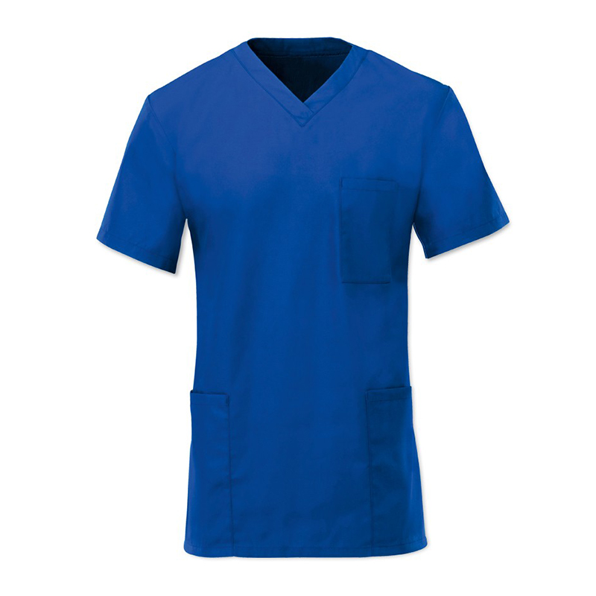

Planned and Unplanned Absences

Planned Absences:
When you are planning to take time off from University, please speak to your programme lead. Also complete the absence form below.
Your programme leads need to have a minimum of 8 weeks notice in order to approve your leave request and cancel any clinical activity that may be impacted by your leave.
Unplanned Absences:
If you are taking an unplanned absence (e.g. if you are unwell), please complete the absence form below.
Online absence form:
This can be found on:
QMplus –
- https://qmplus.qmul.ac.uk/course/view.php?idnumber=Dentistry-Home
- In the student support area.
- Towards the right had side of the screen.
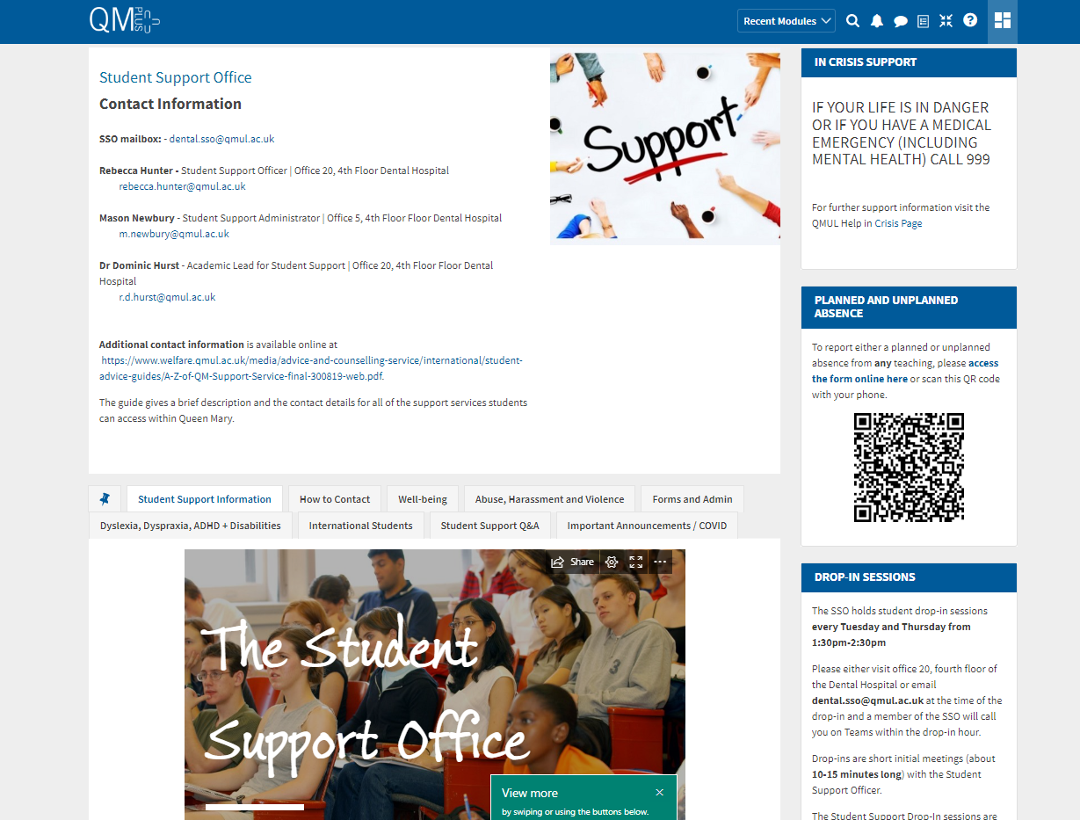
Support and Resources
Here you can find some of the support available to you within QMUL.

Advice and Counselling
Specialist and confidential advice and support for welfare, financial, emotional and psychological issues.
www.welfare.qmul.ac.uk

Disability and Dyslexia Service (DDS)
Confidential advice, guidance and support for students with diagnosed mental health conditions and those who have experienced a mental health crisis, disabled students and students with Autistic Spectrum Conditions (ASC)
www.dds.qmul.ac.uk

Report + Support
An online platform offering for all students to report to QMUL anonymously or with contact details) any incident of sexual violence, harassment or any hate crime. Information about local and national specialist support services is also available.
www.reportandsupport.qmul.ac.uk

Organisations offering support outside of QMUL

- The Havens
Specialist centres in London for people who have been raped or sexually assaulted
https://www.thehavens.org.uk/

- National Domestic Abuse Helpline
https://www.nationaldahelpline.org.uk/en

- Samaritans
www.samaritans.org

- CALM
The campaign against living miserably. 75% of all UK suicides are male. CALM exists to change this.
www.thecalmzone.net

- Papyrus
UK charity dedicated to the prevention of suicide and the promotion of positive mental health and emotional wellbeing in young people.
www.papyrus-uk.org

- Hub of Hope
UK’s leading mental health support database provided by national mental health charity, Chasing the Stigma.
https://hubofhope.co.uk/

- Maytree Respite Centre
A charity offering one-off four night residential sanctuary for people 18+ in a suicidal crisis, in a calm, safe house in north London.
www.maytree.org.uk

- PaNDAS
Postnatal depression awareness and support.
https://pandasfoundation.org.uk/

- Sane
Meeting the challenge of mental illness.
http://www.sane.org.uk/

Contacts

PGT Timetabling and Curriculum Team
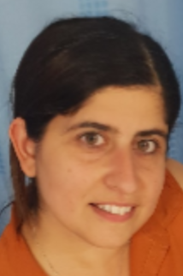 | Abi Soybir | PGT Timetabling Co-ordinator and Curriculum Administrator  Office 5, Fourth Floor  a.soybir@qmul.ac.uk
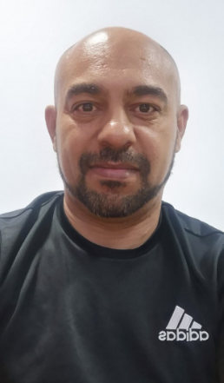 | Antony Cuffe | PGT Timetabling Co-Ordinator  Office 5, Fourth Floor  a.cuffe@qmul.ac.uk
 | William Ng | Education Manager  Office 5, Fourth Floor  william.ng@qmul.ac.uk
 | Bridgette Murillo | Administrator BDS Years 1-5, Administrator to CCFS  b.e.murillo@se22.qmul.ac.uk or b.d.job@qmul.ac.uk  Office 5, Fourth Floor
 | Danielle George- Earle | Programme Administrator  d.george-earle@qmul.ac.uk  Office 5, Fourth Floor
 | Lauren Collins | Programme Administrator  l.c.collins@qmul.ac.uk  Office 5, Fourth Floor
 | Jo Treadgold | Timetabling Coordinator  Office 5, Fourth Floor  Jo.treadgold@qmul.ac.uk
Shared Mailbox
dentistry.ct@qmul.ac.uk

Student Support Office
 | Dr Dominic Hurst | Academic Lead for Student Support  Office 20, Fourth Floor  r.d.hurst@qmul.ac.uk
 | Rebecca (Becky) Hunter | Student Support Officer  Office 20, Fourth Floor  rebecca.hunter@qmul.ac.uk
 | Zara Mabey  And  Zehra Sonerman | Student Support Administrator  Office 5, Fourth Floor  z.sonerman@qmul.ac.uk  z.mabey@qmul.ac.uk
Shared Mailbox
Dental.sso@qmul.ac.uk

Library Services
 | Paula Funnel | Faculty Liaison Librarian  p.a.funnell@qmul.ac.uk
 | Academic Skills Team | Website:  https://www.qmul.ac.uk/library/academic-skills/  Email: academicskills@qmul.ac.uk
Library Webpage
https://www.qmul.ac.uk/library/academic-skills/

Directors of Education
 | Directors of Education  (FMD, QMUL) | Professor Paul Anderson | (IoD) Director of Education  Lead for MSc Oral Biology  p.anderson@qmul.ac.uk
 |  | Dr Janet Davies | (IoD) Deputy Director of Education /  Lead for Paediatric Dentistry  janet.davies@qmul.ac.uk
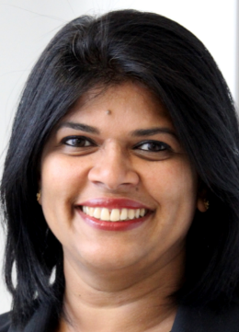 | Director of Dental Education (Barts Health NHS Trust) | Dr Lochana Nanayakkara | l.nanayakkara@nhs.net

Postgraduate Programme Leads

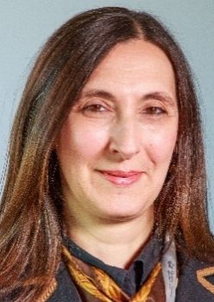 | Dental Sciences for Clinical Practice | Dr Eleni Hagi-Pavli | e.hagi-pavli@qmul.ac.uk
 |  | Dr Cecilia Gonzalez-Marin | c.gonzalesmarin@qmul.ac.uk
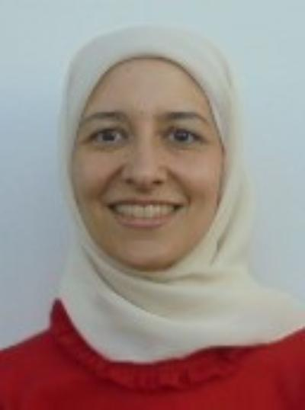 | Endodontics  (DClinDent) | Professor  Samira Al-Saleha | s.al-salehi@qmul.ac.uk
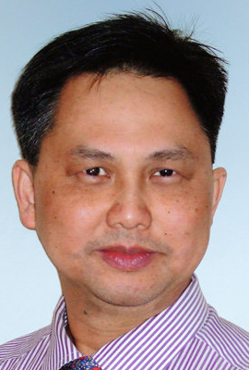 | Endodontic Practice  (MSc) | Dr Bun Chong | b.s.chong@qmul.ac.uk
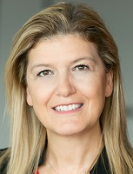 | Minimally Invasive Dentistry | Dr Aylin Baysan | a.baysan@qmul.ac.uk
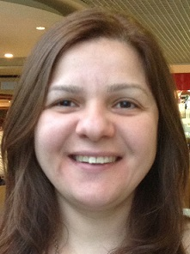 | Oral Microbiology | Dr Noha Seoudi | n.seoudi@qmul.ac.uk
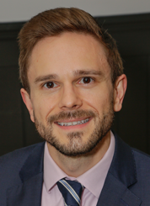 | Oral Surgery | Dr Edmund Bailey | e.bailey@qmul.ac.uk
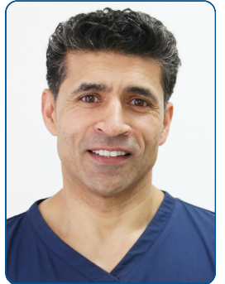 | Orthodontics | Professor Ama Johal | a.s.johal@qmul.ac.uk
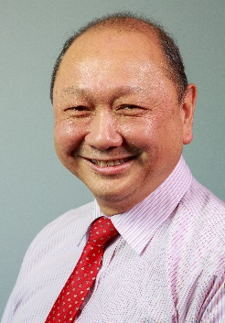 | Paediatric Dentistry | Professor  Ferranti Wong | f.s.l.wong@qmul.ac.uk
 |  | Dr Janet Davies | janet.davies@qmul.ac.uk
 | Periodontics | Dr Domniki Chatzopoulou | d.chatzopoulou@qmul.ac.uk
 | Prosthodontics | Dr Tim Friel | t.friel@qmul.ac.uk
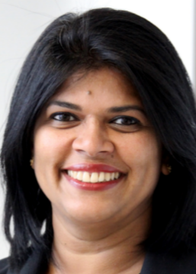 |  | Dr Lochana Nanayakkara | l.nanayakkara@qmul.ac.uk

Students and Locations

Locating the Dental Hospital

The address for the Dental Hospital is:

Turner Street,
Whitechapel,
London,
E1 2AD

- It is located within walking distance of Whitechapel, Shadwell and Aldgate East Underground stations.
- The main entrance on Turner Street gives you access to the main stairs and lifts.
- The dental hospital is open from 8:30AM to 5:30PM.
- There is a staff entrance on Stepney Way accessible with your NHS ID card.
- There is no parking available on site. Some pay and display parking is available on the surrounding streets but can get very busy.
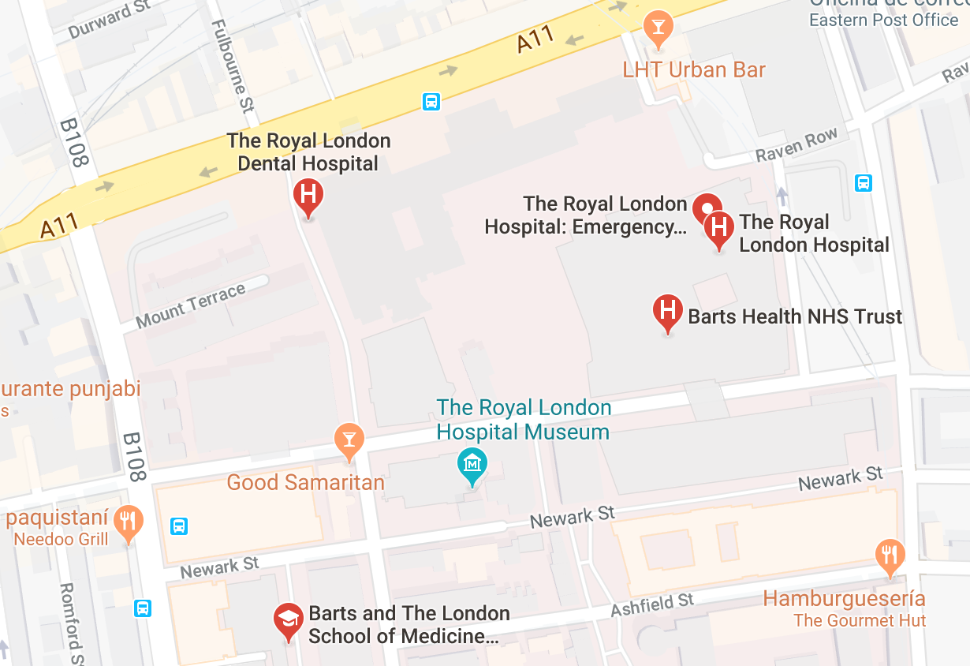

Navigating the Dental Hospital

Floor | What you’ll find
Basement | - Barts Health Education Academy  - Lecture theatres (Bearsted, John Ellis)
Ground Floor | - Restorative Dentistry  - Student bays  - Oral surgery  - Sedation clinic  - Nurse offices  - Stores  - Patient records (B9)
First Floor | - Restorative Dentistry  - Prosthodontics Lab  - Central Sterilising Department  - Oral Surgery  - Paediatric & Orthodontic Departments
Second Floor | - Oral Medicine  - Radiography  - Oral Surgery
Third Floor | - Clinical skills lab  - Pros Lab  - Changing Rooms
Fourth Floor | - Offices 1-10  - 4th floor seminar room  - Junior Staff Office (Office 1)  - Administrators; UG/PG Tutors; Consultants  - Student support office
Fifth Floor | - Dental Deans office  - Administration  - Seminar rooms  - Davenport room

International Students
Welcome to Queen Mary, University of London!
It is an honour to have you here.
Below I have attached some things that I believe are useful to helping you navigate the beginning of your journey at Queen Mary and some useful things that would be incredibly helpful to you during your time here.

Accessing Healthcare for students from outside the UK

Registering with your local GP
It is highly important if you are an international student that you register and sign up with your local GP (General Practitioner). For international students that are unaware, General Practitioner’s (GP’s) are able to help you with any healthcare related or medical issues that you might have, and it should be one of those things that you do when you first start at Queen Mary.
I’ve attached a link down below that highlights how you can access healthcare for students that come from outside of the UK.
Accessing Healthcare for students from outside the UK | Student Health | Queen Mary (qmul.ac.uk)
I’ve also attached a link down below that directs you specifically to Queen Mary’s student health services.
Student Health | Queen Mary (qmul.ac.uk)

Getting Around London
London is incredibly busy, with a significant variety of things to do and places to go to, so understandably it could be very overwhelming to get around.
Down below I’ve attached a map of the tube, so that you can have an insight into what the different trains and tube-lines consist of, and all the different journeys that you can make to get around London.
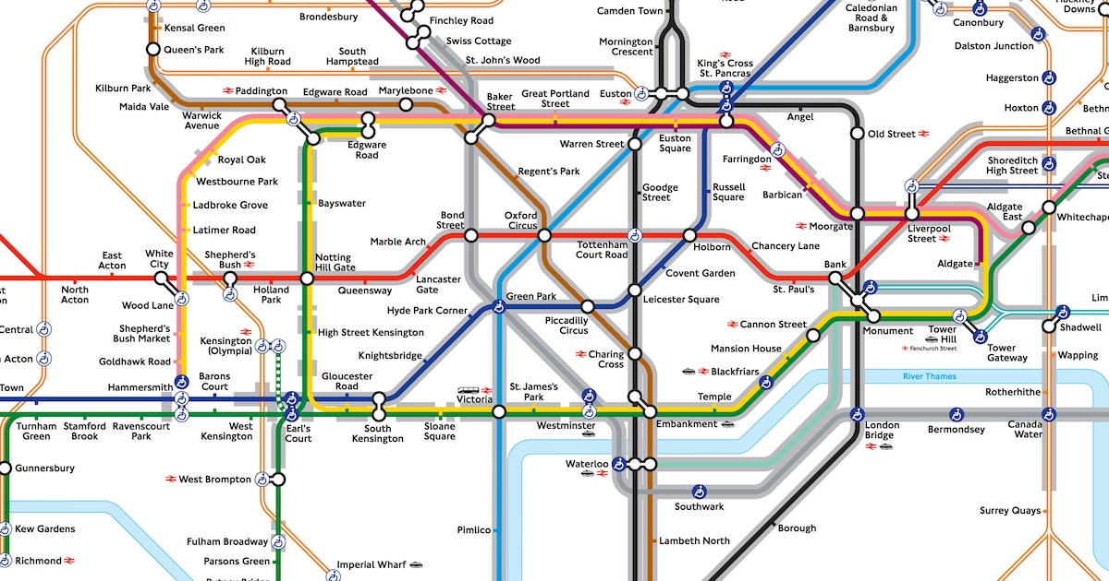

For trains to Whitechapel
There are numerous train lines and tubes that help you get into the Whitechapel campus.
The London overground, the London underground and the Elizabeth line all go to Whitechapel station, which is located incredibly close to the Whitechapel dental hospital.
Buses to Whitechapel
There are also many buses that also can take you near the Whitechapel Royal London dental hospital such as the 25, the 205, the 254, the N25, N205 and N253 depending on where you are coming from.

General
Down below I’ve attached a link that is for all students, it is a link that directs you to a page that will help you with any enquiries that you might have.
Course: Student Support (qmul.ac.uk)
A home from home - Queen Mary University of London (qmul.ac.uk)
International students - Queen Mary University of London (qmul.ac.uk)

Student Support
The Student Support office is always here to help students.
I have attached a link below to the Queen Mary QM+ page, that has a student support page on all the support that the student support office has to offer to all students, as well as what the student support office does.
Course: Student Support (qmul.ac.uk)
The QM+ student support page highlights all the different ways the Student Support office is there to help. The student support page for QM+ also has sections that are more specific to any enquiries that you might have, for example if you were enquiring about welfare, forms, admin, intercalating and much more.
Course: Student Support (qmul.ac.uk)

Welfare, Immigration and Visas
For any welfare, finance or funding or immigration and visa issues please do contact welfare@qmul.ac.uk , as they will help solve all your visa, immigration and welfare issues, as well as being able to help you with any advice and counselling that you may require.
There is also a Queen Mary welfare page that I’ve attached down below, which will give you an insight into the different support services available from the welfare team.
Advice and Counselling Service - Advice and Counselling Service (qmul.ac.uk)
There is also a web-form that students may use to contact the welfare team; I have attached the link down below.
Contact us - Advice and Counselling Service (qmul.ac.uk)

Student Union
The Student Union is a student-led organisation that is here to represent and support you during your time here and to make sure your experience at Queen Mary is the best it can be.
I’ve attached a link down below that highlights what the Student Union is and what sources they have available.
Students' Union - Queen Mary University of London (qmul.ac.uk)
Conclusion
To conclude, it may feel very overwhelming starting university or going through any kind of new transition in your life, but here at Queen Mary we want to ease you into that transition as smoothy as possible and we want to help you as much as we possibly can.
Through creating induction handbooks, highlighting the different student support spaces available and through illustrating that we are here to support you, I hope that you feel less alone, and I hope that you that you feel much more welcomed into the new space that you are joining.

