An introduction to QM+

QM+ is our “virtual learning environment”.
Here you will find teaching and administration materials, assessments, grades and much more.

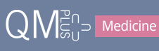

Contents
MBBS Course structure in QM+ 2
Login to QM+ 2
A. MBBS Course Page 3
B. Year Information Portal Page (see the new look edit button here) 4
Useful links found on the bottom of every page 5
C. A Module Page 6

MY QMPLUS DASHBOARD – customising QM+ for you 7

What’s new in the text editor? 8
What’s new within Activities and Resources? 10

MBBS Course structure in QM+
^ Staff
^ Students
B. Year Portal
Year handbook,
Assessments

C. Module
Module handbook,
Teaching material

Login to QM+
Login to QM+ with your QMUL username and password. https://qmplus.qmul.ac.uk
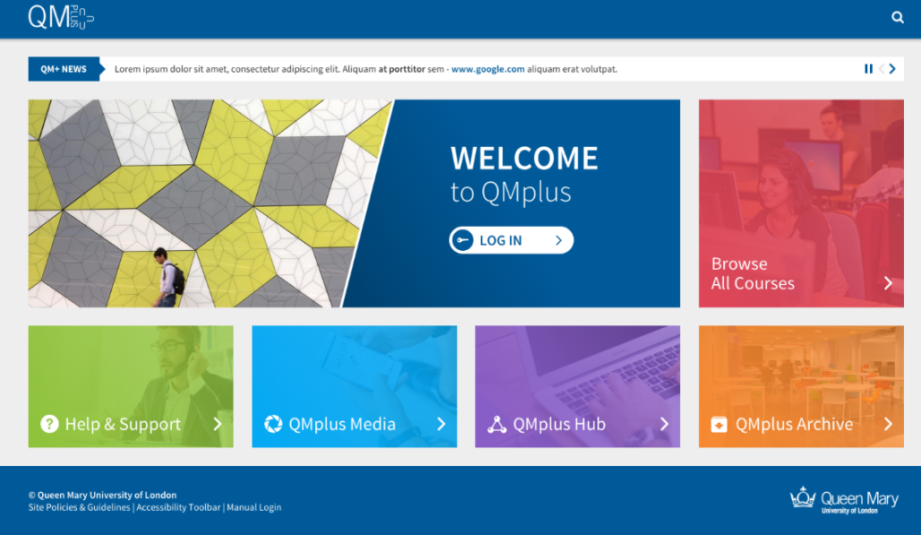
When you first login you will be taken to the My QM+ Dashboard page. If you are enrolled in modules from more than one School/Institute/Faculty you will be asked to choose which one you want to be your homepage.
Logout of QM+
To log out of QM+, click on the icon which is on the top right of the module pages and then click on the logout button on the top right of the navigation bar.
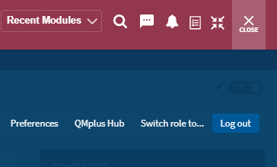

A. MBBS Course Page
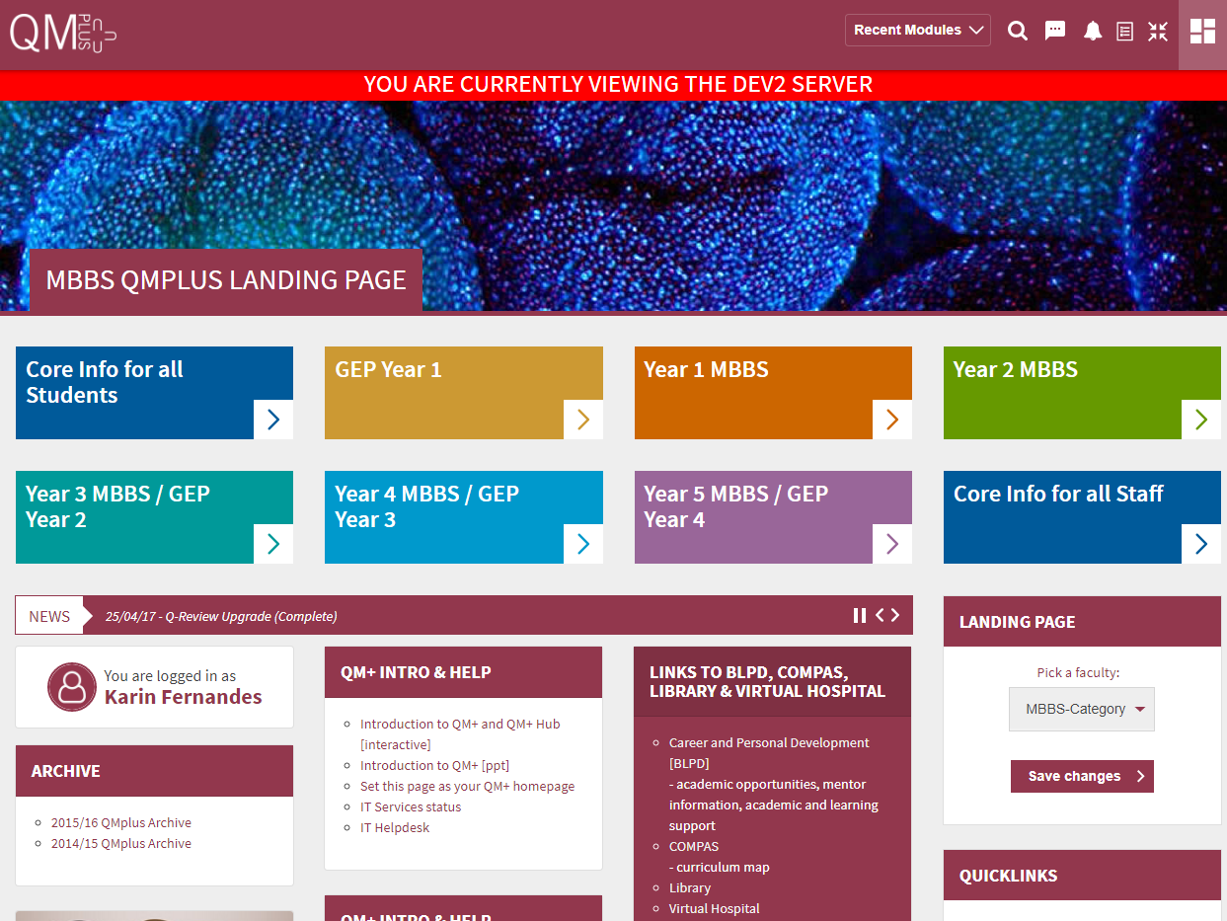
< Link to Year Portal Page
Links to QM+ intro & help, archives, BLPD, COMPAS, Virtual Hospital ...
BLPD – for students: careers & personal development, understand the mentor scheme, studying guide, academic opportunities (research & prizes), Intercalated degree information etc.
COMPAS – for module outcomes & learning objectives.
Virtual Hospital – junior doctors have created virtual patients from their experiences of GP practices and hospitals. Students can use these resources to see different common conditions, consolidate and test their learning. Revise and review drugs, radiology and prescribing skills.

These options are found at the top right of the QM+ pages:
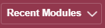 Click here to view your recently accessed courses.
Search for modules.
You can see if you have received new messages here and send messages too.
You can see notifications here e.g. for assignments, feedback, quiz submissions etc.
This is a link to an activity to do list.
This removes or puts back the breadcrumb navigation.

B. Year Information Portal Page (see the new look edit button here)
< Click here to
switch editing
off and on
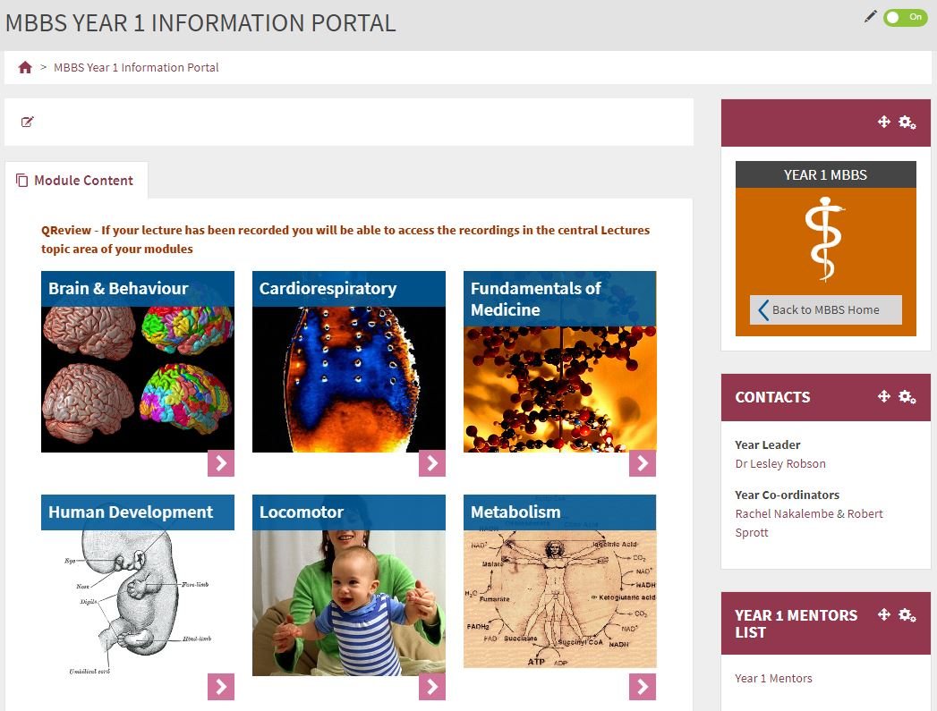
Side blocks contain useful information
< Breadcrumb allowing you to go back
Centre blocks link to modules
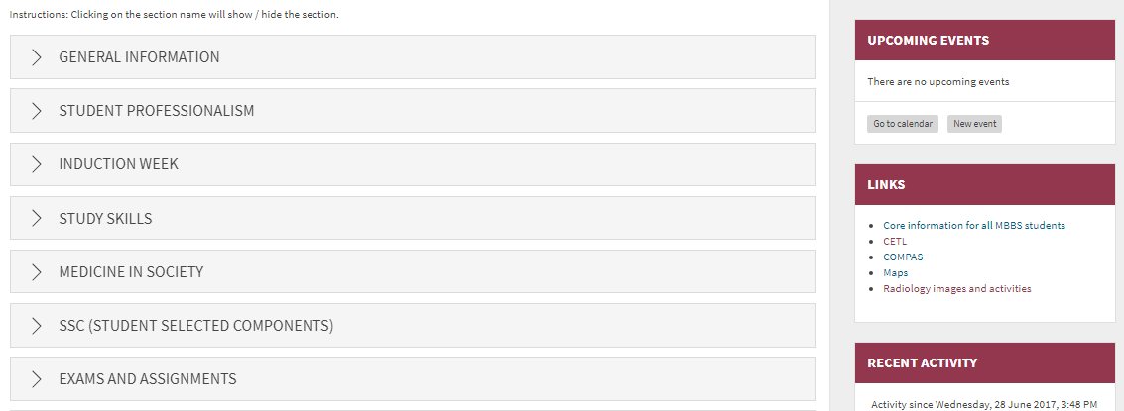
Information,
Allocations,
Assignments.
Click on a title to view the material within a section
A typical section is shown below.
Click on the titles to view material. Click on the pin on the left to save a link to content on your Dashboard.
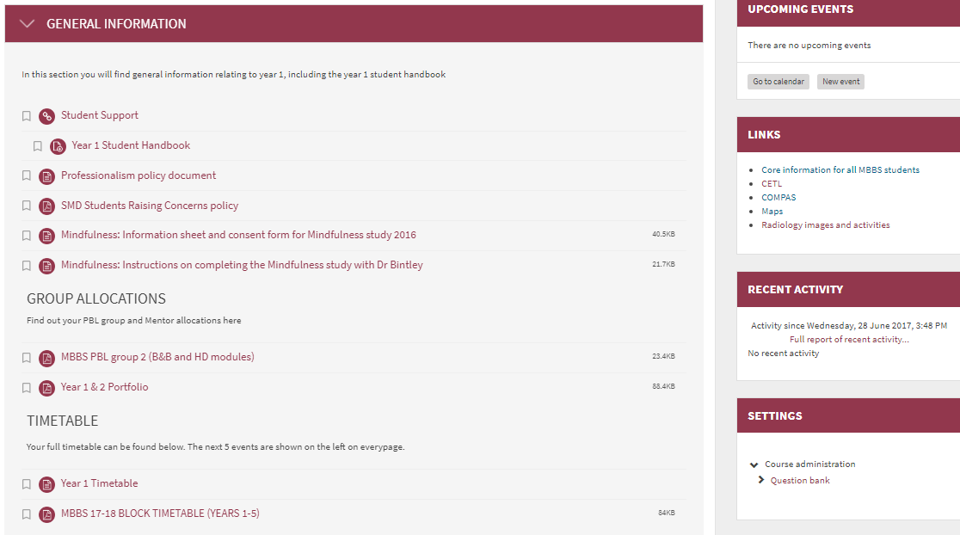

Useful links found on the bottom of every page

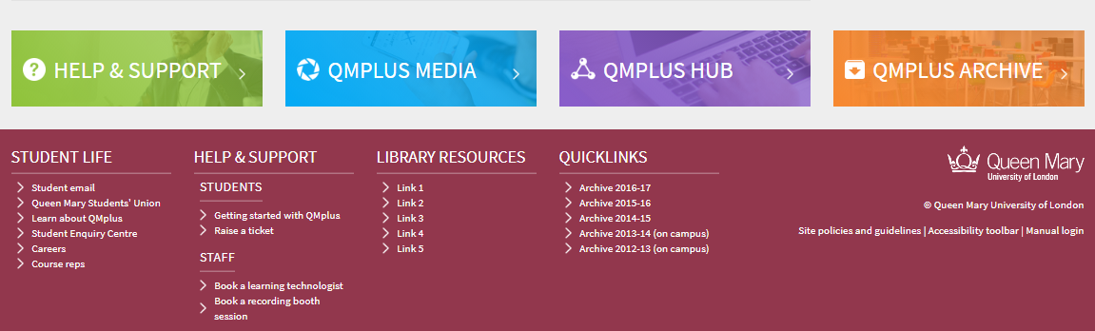
QM+ Help & Support – QM+ guides for students, IT Helpdesk
QM+ Media - Links to videos
QM+ Archive – this takes you to the archived QM+ MBBS areas
QM+ Hub
This is an area of QM+ which you can use to create a portfolio of your work during your time at QMUL.
- You can use this to maintain & share a portfolio of achievement
- You can use it to keep work, feedback and awards
You can also use QM+ Hub to organise and share information with others
- To find out more click ‘help and support’ and look at the QM+ Hub guide

Additional links can be found at the very bottom of the webpages e.g. to library resources and QM+ archives.

C. A Module Page
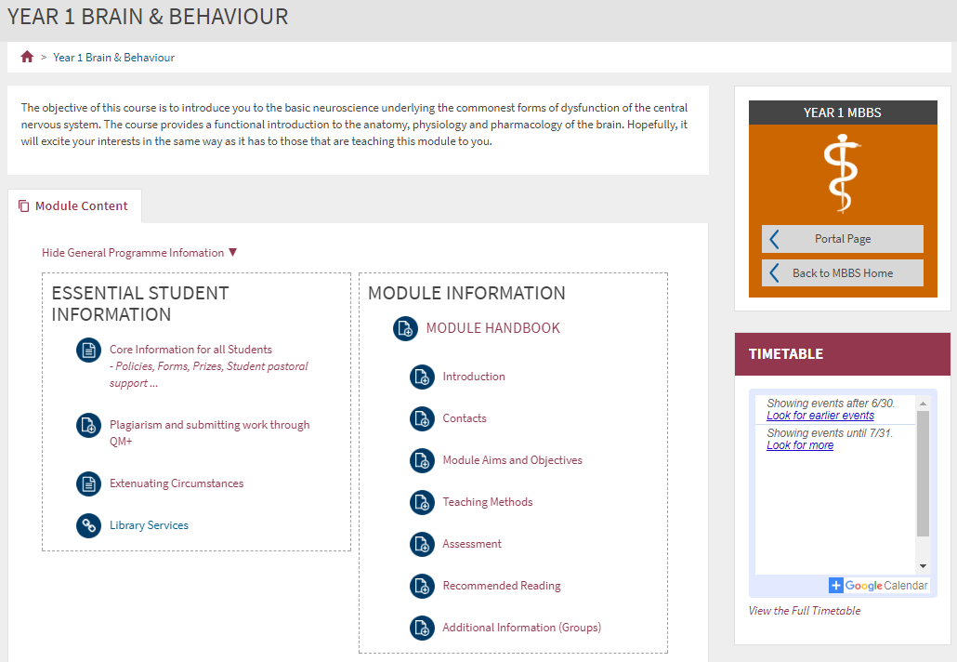
Module Handbook
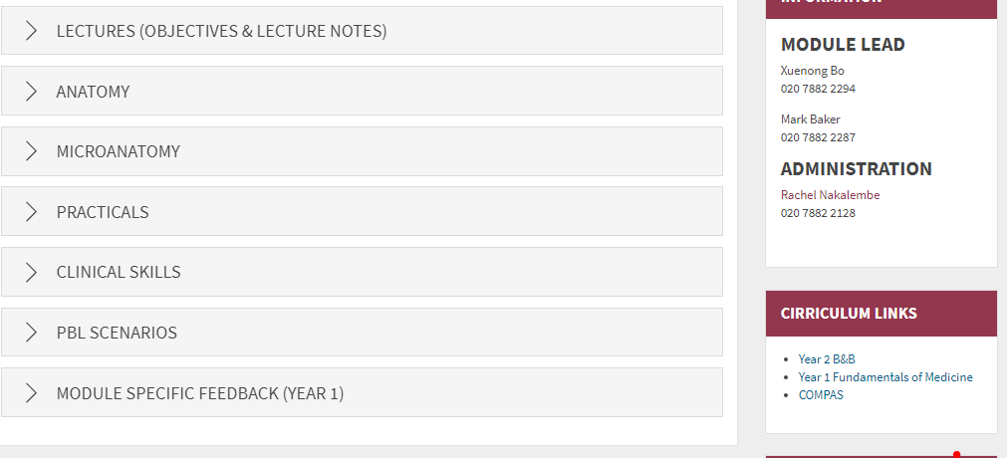
Teaching & Teaching Support Material
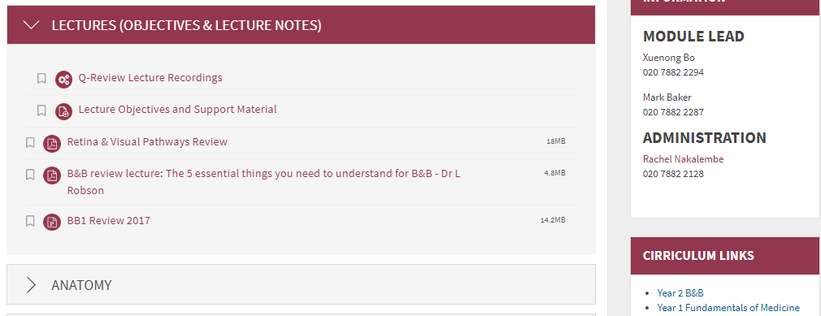
< Handbooks and teaching material (objectives, handouts, etc).
The material can be printed out and kept (either on paper or as a PDF) using the ‘Print Book’ function found in the settings block on the bottom right of the page.
< Lecture recordings

MY QMPLUS DASHBOARD – customising QM+ for you
This is the My Dashboard icon. Note: closing the dashboard takes you back to your module. There are four main areas that make up the Dashboard.
4

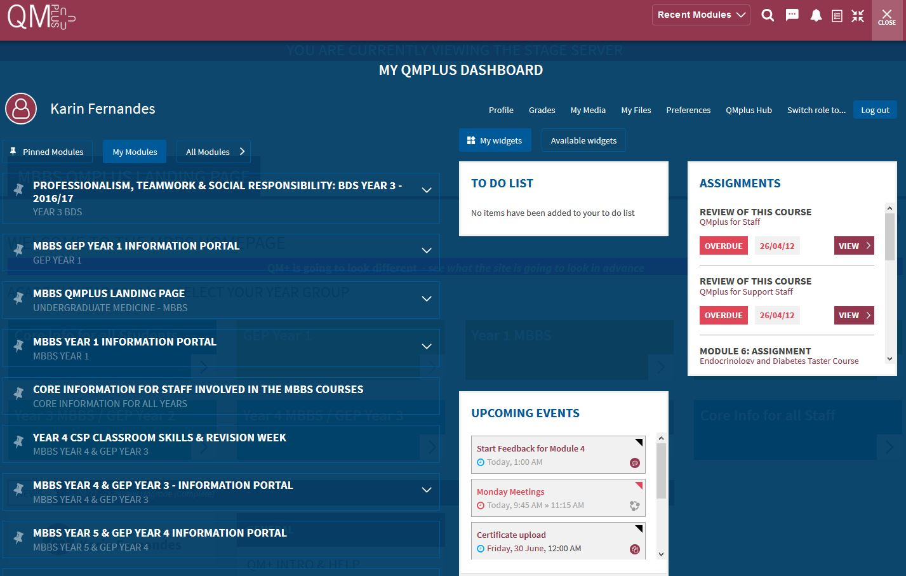
2

3

1

Area 1
When you login to QM+ you will see all the modules you are enrolled in.
To save time scrolling to find your modules, you can pin your current modules by clicking on the pin tool on left of the module title. This creates bookmarks to the modules within the Pinned Modules tab which is saved and can be accessed by clicking on the Pinned Modules tab whenever you login to QM+.
If you click on the title of the module it will take you to your module.
If you click on the you can see if you have assessments that are due.
(If you click on the All Modules tab you are taken to all the QM+ faculties).
Area 2
You can customise your dashboard by adding widgets. Three widgets are available for you to add to your My Widgets tab - Assignments, To do list, and Upcoming Events. More widgets will be added in future.
To select the widget click on the Available widgets tab and click on the + sign next to the widgets that are listed. Click on the My widgets tab to see the widgets in action.
- The to-do list widget works in tandem with the new to-do list feature. Select activities and resources from QMplus modules and add them to the to-do list. Add due dates and additional notes to each item. The to-do list widget on the dashboard will display the lastest 5 to-do items. These will be displayed in date order by default with the option to change the ordering. There are also links to quickly jump to the specific item and a link to review the full list of to-do items.
- The upcoming events widget draws from the users QMplus calendar – This widget will display up to
5 upcoming events. For each event it will display the type (event colour and icon), event name, a link to the event and the event date. Site, Group, Course and user events will all be displayed in this widget. For each event there will be a link to the standard QM+ calendar.
- The upcoming assignments widget displays the top 5 assignments that are due from modules listed in the due date ascending order. If there are more a link to more assignments will appear. Assignments status will be displayed too e.g. due soon (in the next two weeks), submitted or overdue.
Area 3
There are quick links to customise your profile.
Links to the grades and feedback.
From here you can Switch your role to Student to see what the webpages will look like for students.
Area 4
These options are also available on other QM+ pages.
Click here to view your recently accessed courses.
Search for modules.
You can see if you have received new messages here and send messages too.
You can see notifications here e.g. for assignments, feedback, your quiz submissions etc.
This is a link to your activity to do list.
This removes or puts back the breadcrumb navigation.

What’s new in the text editor?
The text (Atto) editor has more options.
Style text using by clicking on the header icon
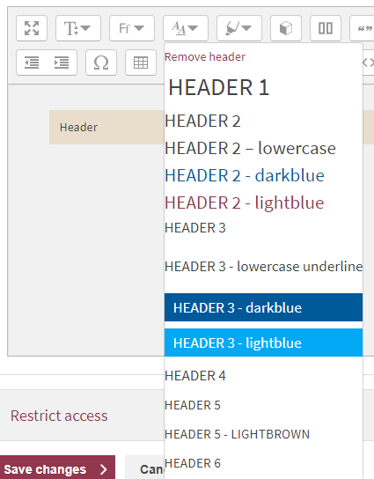
The highlighter pen has options to style titles or remove styles. Select the text, click on the highlighter pen, choose the style. [ Tip: To remove a style from part of a line of text, click the return button at the point where you want to remove the style so the text is on a new line, select the text and go to the highlighter pen and click on Remove highlight].
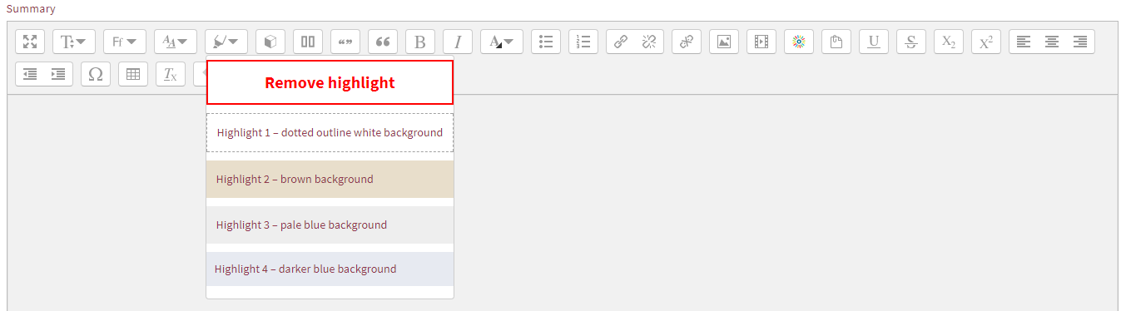

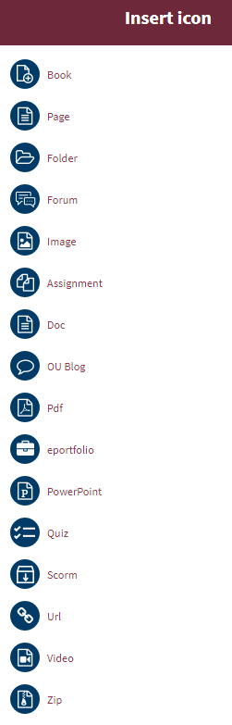
Click on the QM+ icons to insert any of the icons shown on the left.
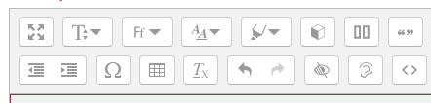
Check the accessibility of your course material.
Click on the column icon to have the option to add one or two columns

What’s new within Activities and Resources?
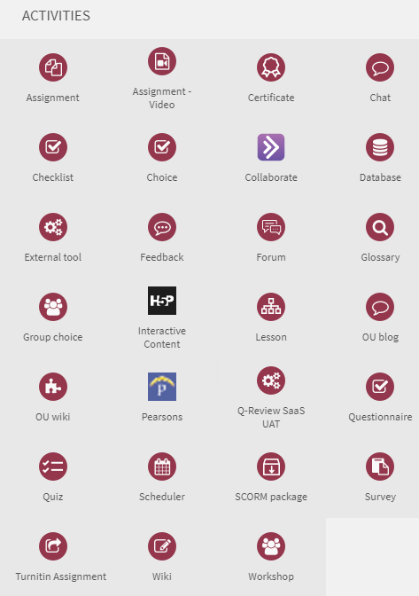
There is a Choice activity that can be used to allow students to select which group they want to be in. The numbers in a group can be limited. An alternative use is to allow students to give feedback by choosing from a list of options.

Students can submit assignments in video format.

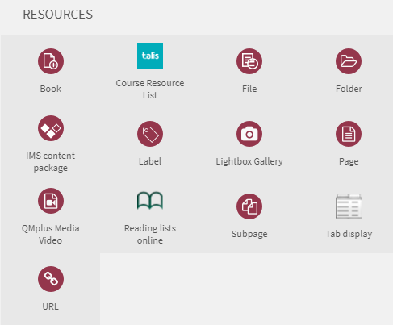
The tab display module allows you to setup your information in a tabbed format. This helps to clean up your course by combining several resources into Tabs.

